

**Green University of Bangladesh**

**Department of Computer Science and Engineering(CSE)**

**Faculty of Sciences and Engineering**

**Semester: (Summer, Year:2021), B.Sc. in CSE (Day)**

LAB REPORT NO 01

Course Title: Database System lab

Course Code: CSE-210                 Section:193DB

**Lab Experiment Name:** Implementation of Integrity constraints in MySQL(Primary Key, Composite Key, Unique, Foreign Key)

**Student Details**

|  |  |  |
| --- | --- | --- |
| Name | | ID |
| 1. | Nazifa Alam Nowrin | 193002101 |

Lab Date : 17.06.2021

Submission Date : 04.07.2021

Course Teacher’s Name : Fatema Tuj Johora

|  |
| --- |
| Lab Report Status  Marks: …………………………………                              Signature:.....................  Comments:..............................................                              Date:.............................. |

Primary key:

CREATE TABLE cos(

name varchar(50),

id int(10) PRIMARY KEY,

phone int(20)

);

Output:

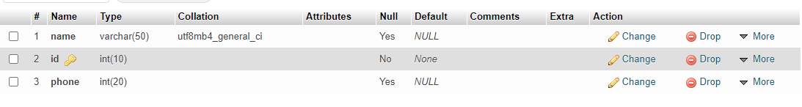

Composite key:

CREATE TABLE student_id(

CREATE TABLE student(

Id int(10),

name varchar(20),

email int(10),

PRIMARY KEY(Id,email)

);

Output:

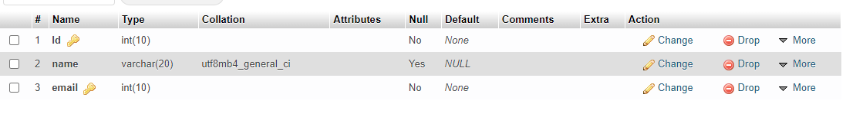

Unique key:

CREATE TABLE teacher(

Id int ,

Name VARCHAR(40) ,

City VARCHAR(50),

CONSTRAINT UK_CUSTOMER UNIQUE (Id,Name)

);

Output:

